**Brain Tumor Detection using VGG16 transfer learning model**

Mithunraj, mithunraj.m06@gmail.coam

Karnesh, karnesh.2022@vitstudent.ac.in

Ritish Reddy, ruyyadiritish.reddy2022@vitstudent.ac.in

**Abstract**

This study explores the field of medical image analysis, specifically concentrating on using deep learning methods to classify brain tumors. The main focus is on utilizing a Convolutional Neural Network (CNN) with the VGG16 architecture and transfer learning techniques. The study is driven by the challenges of interpreting neurological medical images and seeks to improve healthcare processes by automating the precise detection of brain tumors. By using a meticulously labeled dataset, the VGG16 base model undergoes fine-tuning in a two-phase training process, demonstrating its capability to adjust to the complexities of brain tumor classification. The study focuses on exploring Grad-CAM and attention mechanisms with an emphasis on interpretability. In the future, this study paves the way for new innovations by

recommending the expansion of the dataset, partnering with medical professionals, and ongoing refinement of the model to enhance patient outcomes. The Python script that comes with this demonstrates a detailed implementation of the CNN. It shows the training and evaluation processes and includes visualization of key metrics.

*Keywords*: image processing; brain tumor; deep learning; VGG16 Architecture; convolutional neural networks

**1. Introduction**

In the realm of medical image analysis, the application of deep learning techniques has emerged as a transformative force, offering unprecedented capabilities for the accurate and efficient classification of diseases. Brain tumor classification, a critical area within medical imaging, stands to benefit significantly from advancements in deep learning methodologies. This study undertakes the development of a Convolutional Neural Network (CNN)[1] for the meticulous classification of brain tumor images, employing the influential transfer learning paradigm with the renowned VGG16 architecture.

The motivation behind this study[2] is rooted in the complex nature of interpreting medical images, especially those related to neurological conditions. The ability to automatically and accurately identify the presence of brain tumors in medical scans not only facilitates timely diagnosis but also enhances the overall efficiency and precision of healthcare workflows. Leveraging transfer learning with the [3]VGG16 architecture, a model is trained to harness the pre-existing knowledge ingrained in the VGG16 model, which was originally trained on a diverse set of images, most notably the ImageNet dataset.

The dataset utilized in this study[4] is a compilation of brain images categorized into 'normal' and 'tumor' classes. This dataset forms the backbone for the training and evaluation of the model, reflecting the inherent challenges and variations present in real-world medical images. The preprocessing phase plays a pivotal role in ensuring that the input images are appropriately resized, normalized, and formatted to be compatible with the VGG16 architecture. Furthermore, the dataset is meticulously labeled, and a strategic split into training and testing sets is executed to facilitate robust model training and evaluation.

The VGG16 base model[5], serving as the foundation of the CNN, is initialized with pre-trained ImageNet weights. This strategic choice allows the model to inherit knowledge about general features from a broad range of objects and patterns, providing a head start in recognizing salient features in brain tumor images. The subsequent addition of custom layers, including flattening and densely connected layers, tailors the model to the specific task of brain tumor classification.

The training process unfolds in two distinct phases[6]. Initially, the model undergoes training on the preprocessed training data, where it refines its parameters to accurately map input images to their corresponding labels. This phase is essential for instilling a foundational understanding of the dataset in the model. Following this, the model embarks on a fine-tuning journey, where the last few layers of the VGG16 base are unfrozen, allowing them to adapt to the nuances of the brain tumor dataset. Fine-tuning serves as a critical step in aligning the model's learned features with the intricacies of the specific classification task at hand.

A key aspect of the study[7] lies in the comprehensive evaluation of the model's performance. The accuracy metric provides a holistic measure of the model's correctness in its predictions, indicating the percentage of correctly classified instances out of the total. However, accuracy alone may not reveal the complete story, especially in scenarios where class imbalances exist. Hence, the confusion matrix, detailing true positives, true negatives, false positives, and false negatives, offers valuable insights into the model's performance for each class.

The Receiver Operating Characteristic (ROC) curve[8] complements these metrics by visualizing the trade-off between true positive rate and false positive rate across different classification thresholds. The area under the ROC curve (AUC) serves as a quantitative measure of the model's discriminatory ability. These evaluation metrics collectively furnish a nuanced understanding of the model's strengths and potential areas for improvement.

Beyond quantitative metrics[9], this study also places a strong emphasis on the interpretability of the model. Explorations into techniques such as Grad-CAM (Gradient-weighted Class Activation Mapping) or attention mechanisms facilitate the visualization of regions in input images that significantly influence the model's decision-making. This interpretability aspect is crucial, particularly in medical applications, where trust in the model's decisions is paramount.

Looking forward, this study[10] sets the stage for future endeavors in the intersection of deep learning and medical imaging. The dataset used can be expanded to incorporate a more extensive and diverse set of brain images, fostering increased model robustness and generalization. Exploring alternative architectures or integrating additional modalities, such as multi-modal imaging, could further enhance the model's diagnostic capabilities.

Collaboration with medical professionals[11] and the integration of clinical data represent avenues for refining the model and aligning it more closely with real-world medical practices. Continuous monitoring and updating of the model with new data and advancements in the field ensure its relevance and effectiveness over time.

In conclusion, the development of a CNN for brain tumor classification using transfer learning with the VGG16 architecture is a significant stride towards leveraging the potential of deep learning in medical diagnostics. This study not only showcases the technical intricacies of model development but also underscores the importance of interpretability and real-world applicability in the context of healthcare. As the study unfolds, it lays a foundation for future innovations that bridge the gap between cutting-edge technology and improved patient outcomes.

**2.RelatedWork**

The manipulation of a two-dimensional image using a digital computer is known as digital image processing, and it can also refer to the digital processing of any two-dimensional data in a broader sense. An array of real numbers in a finite number of bits represents a digital image. Digital image processing methods have several key advantages, including their versatility, repeatability, and ability to preserve original data precision. Image processing involves several key techniques such as image preprocessing, enhancement, segmentation, feature extraction, and classification. [12] discussed the different image processing techniques.  
  
 Pre-processing of images is used to correct errors in geometry and brightness values in satellite sensor data. This correction is accomplished through the use of mathematical models, whether they are deterministic or statistical. Image enhancement involves adjusting the brightness of pixels to enhance the visual impact, improving contrast and addressing limitations in brightness in images captured by satellites or cameras. Some enhancement techniques, such as contrast stretching, noise filtering, histogram modification, and several others, are used to improve the quality of images.  
Contrast stretching is used on uniform images[13] with minimal variation in pixel levels. This technique extends the spectrum of gray levels in order to improve understandability. The process of noise filtering in images involves removing unwanted information and different types of noise using filters such as low pass, high pass, mean, and median. Histogram modification, like Histogram Equalization, changes the histogram to adjust image qualities, thereby enhancing contrast and improving overall interpretation. In general, image enhancement focuses on highlighting certain image characteristics for analysis or display without adding more inherent information.  
 Image segmentation is an essential component of image processing as it entails the partitioning of an image into its individual components or objects. Image thresholding techniques are often used to segment images, creating a binary image that separates object pixels from background pixels.  
 When performing thresholding, the grayscale values are converted into binary values {0, 1}. The value of the segmented image (S) is based on the gray level of the pixel (g) and a threshold value (T). It is crucial to choose the right threshold, and there are several suggested methods for automatically selecting the threshold. If there are two distinct peaks in the gray level histogram, one threshold for the entire image could be enough. Nevertheless, in the event that the histogram exhibits a single peak, it is necessary to employ local binarization techniques.  
 Segmentation not only distinguishes[14] between objects and background, but it also divides different regions within an image. Feature extraction techniques are incredibly important, especially in synthetic aperture radar images. These techniques extract high-level features like size, shape, composition, and location for target classification.  
 Feature extraction has a significant impact on the efficiency of the recognition system. The selection of an appropriate feature extraction method is essential in order to achieve a high recognition performance.  
 The simulation results of the proposed algorithm demonstrate enhanced performance when using the total transmission energy metric as opposed to the maximum number of hops metric. The goal of the algorithm is to find a path for data transmission that is energy-efficient, with the aim of maximizing the lifetime of the network. Image classification is the process of assigning labels to pixels based on their gray value, and it is widely used for extracting information.

In recent years, there has been a growing interest in the application of artificial neural networks (ANNs) in medical image processing[15]. The article by Zhenghao Shi and Lifeng He , provides an overview of the approaches and create a map of ANNs used in medical image processing, focusing on three main topics: medical image preprocessing, medical image segmentation, and medical image object detection and recognition. The discussion avoids delving into specific algorithms or comparative experiment results but rather summarizes main approaches and highlights interesting aspects of neural networks in medical image processing. The primary focus is on answering the major strengths and weaknesses of applying ANNs in this context.

Image preprocessing with neural networks[16] involves image reconstruction and restoration. The Hopfield neural network is prominently used for image reconstruction, addressing medical image reconstruction as an optimization problem. For image restoration, neural networks, including feed-forward, fuzzy, and cellular neural networks, are applied. Neural network-based filters (NFs) and a supervised edge enhancer called neural edge enhancer (NEE) have been developed for noise removal and edge enhancement, respectively.

Feed-forward neural networks[17] are widely used for medical image segmentation, demonstrating less noisy segmented images compared to traditional methods. However, these methods often have slow convergence rates and require a priori learning parameters. Hopfield neural networks are also employed for segmentation, presenting an alternative to traditional optimization algorithms in solving complex optimization problems related to medical image reconstruction.

In the realm of medical image detection and recognition[18], the backpropagation neural network emerges prominently, as evidenced by 11 out of 23 reviewed papers employing it. These applications span various medical scenarios, including mammogram interpretation, cold lesion detection in SPECT images, diagnosis of liver diseases based on ultrasonography, separation of melanoma from benign tumors, distinguishing interstitial lung diseases, and reducing false positives in the computerized detection of lung nodules in LDCT and chest radiography. The feedforward neural network-based methods consistently exhibit a preference for improved recognition accuracy and computational efficiency over conventional approaches.

Additionally, various other neural networks[19], such as the Hopfield neural network, ART neural network, radial basis function neural network, Probabilistic Neural Network, convolutional neural network, and fuzzy neural network, have secured their positions in medical image detection and recognition,

common features beneficial to each task. In 2005, DARPA's Information Processing Technology Office introduced a mission for transfer learning, emphasizing the system's ability to recognize and apply knowledge learned in previous tasks to novel tasks. Unlike multi-task learning, transfer learning prioritizes the target task, extracting knowledge from source tasks to enhance performance in the target task. The roles of source and target tasks are not symmetric in transfer learning.

Utilizing Transfer Learning with Pretrained Models

The ImageNet[20] study focuses on constructing a comprehensive database of annotated images, providing both images and their corresponding labels. Pretrained models such as InceptionV1, Inception V2, VGG-16, and VGG-19 have already undergone training on ImageNet, which encompasses diverse image categories. These models are developed from the ground up and trained using powerful GPUs on millions of images spanning thousands of categories.

Given their extensive training on a vast dataset, these models have acquired a robust understanding of low-level features, including spatial characteristics, edges, rotation, lighting, and shapes. These learned features can be shared across different computer vision problems, enabling knowledge transfer and serving as effective feature extractors for new images. Despite these new images potentially belonging to entirely different categories than those in the source dataset, pretrained models are designed to extract relevant features through the principles of transfer learning.

This paper explores the potential of transfer learning[21] by employing the pretrained VGG-16 model as a powerful feature extractor. The objective is to classify images of dogs versus cats even with a limited number of training images, showcasing the effectiveness of transfer learning in practical scenarios.

**3. Methodology**

**3.1 Classifier model**

The study is a classifier model which is used to classify whether the image which is inputted has brain tumor or not.this model uses two kinds of dataset namely images with tumor and images without tumor . The following dataset was obtained through kaggle.

**3.2 Transfer learning VGG16**

VGG16 operates by processing input images through a series of convolutional layers, each layer extracting increasingly complex features from the image. The network's architecture is characterized by its deep stack of convolutional layers, which helps it learn hierarchical representations of visual patterns. The convolutional layers are followed by max-pooling layers, reducing spatial dimensions and retaining essential features. The resulting features are then flattened and fed into fully connected layers for final classification. During transfer learning, the pretrained VGG16 model's weights, learned from a large dataset, are utilized to extract general features. The top layers specific to the original task are replaced with custom layers tailored to the new task, and the model is fine-tuned on a smaller dataset. This process leverages the knowledge gained from the pre-training, enabling effective adaptation to new image classification tasks with limited data.

**3.3 Pre trained weights.**

ImageNet pre-trained weights in deep learning models, such as VGG16, are a result of training on a massive dataset called ImageNet, which contains millions of labeled images spanning thousands of categories. During this pre-training phase, the model learns to recognize a diverse range of features, patterns, and objects present in images. The convolutional layers in the network capture low-level features like edges and textures, while deeper layers progressively assemble more complex and abstract representations. These pre-trained weights act as a knowledge base for the model, encoding a rich understanding of visual features. When these weights are transferred to a new task, the model starts with a foundation of generalized knowledge, making it proficient at extracting relevant features for a variety of image recognition tasks. Fine-tuning on a specific dataset for the target task refines the model's weights, adapting it to the nuances of the new data while retaining the valuable insights gained from the original ImageNet pre-training.

**4.ProposedModel**

DATA LOADING AND PREPROCESSING

DATA SPLITTING

VGG16 MODEL INITIALIZATION

MODEL ARCHITECTURE

INITIAL TRAINING

FINE TUNING

INDIVIDUAL PREDICTION

Figure 1: Workflow model

Figure1, shows that the first step is data loading and data splitting. The dataset obtained from Kaggle containing the two datasets, namely brain with tumor and brain without tumor. This dataset is imported into the model using the os package.

The dataset is then preprocessed by resizing to 224x224 pixels, normalizing pixel values, and storing them in a NumPy array named data. Labels are assigned ('Normal' or 'Tumor') and encoded using scikit-learn's LabelEncoder. The dataset is then split into training data and testing data with 80% for training and 20%for testing.

We then proceed to initialize the VGG16 base model with pre-trained ImageNet weights. The top layers responsible for the original ImageNet classification are removed, leaving only the convolutional base. The weights of this base are frozen to retain pre-trained knowledge. Additional layers, including flattening and densely connected layers, are added to form the complete model. The model is compiled using the Adam optimizer and sparse categorical crossentropy loss suitable for multi-class classification.

The training phase begins with the model being trained on the preprocessed training data for 10 epochs. Training and validation accuracy, as well as loss, are recorded for later visualization. Following the initial training, the script fine-tunes the model by unfreezing the last few layers of the VGG16 base, allowing them to be trainable. Another set of training is performed, and accuracy and loss are recorded.

**5.Experimentation**

**Result/ResultsAnalysis** In the context of machine learning, training loss and validation loss are crucial metrics that provide insights into the performance of a model during the training process. The training loss represents the cumulative error or discrepancy between the predicted values and the actual ground truth labels calculated during each iteration of the training phase. It quantifies how well the model is learning from the training data. On the other hand, the validation loss measures the performance of the model on a separate dataset that it has not seen during training, often referred to as the validation set. This metric helps assess the model's ability to generalize to new, unseen data. During training, the goal is to minimize both the training and validation losses, ensuring that the model learns patterns from the training data while maintaining the capacity to make accurate predictions on new, previously unseen examples. Monitoring the trends of these loss values over epochs aids in understanding the model's convergence, potential overfitting, or underfitting, guiding adjustments to improve overall performance. A widening gap between training and validation losses may indicate overfitting, emphasizing the importance of balancing model complexity and generalization.

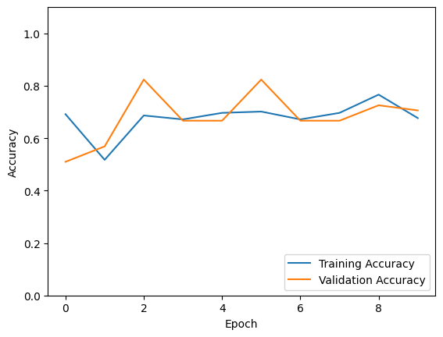

Figure2. Graph showing training accuracy and validation accuracy.

Figure 2, shows the graph for training accuracy and validation accuracy of neural network model that is fine-tuned with some of the layers in the VGG16 model being trainable.

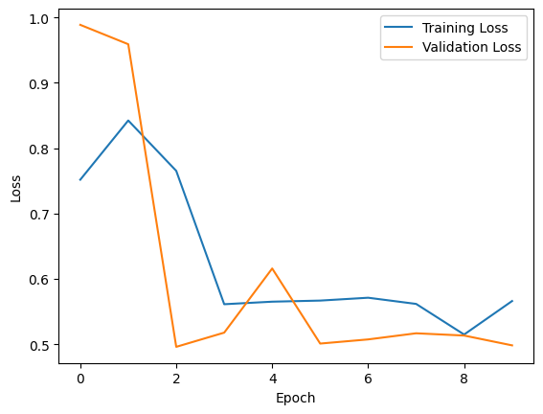

Figure 3: graph showing training loss and validation loss.

Figure 3, shows the graph for training loss and validation loss of neural network model that is fine-tuned with some of the layers in the VGG16 model being trainable.

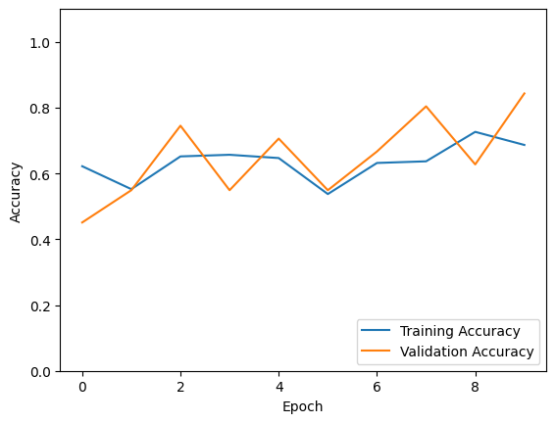

Figure 4: Graph showing the training accuracy and validation accuracy

Figure 4, shows the graph for training accuracy and validation accuracy of neural network model where all the layers in the VGG16 model are frozen (non-trainable).

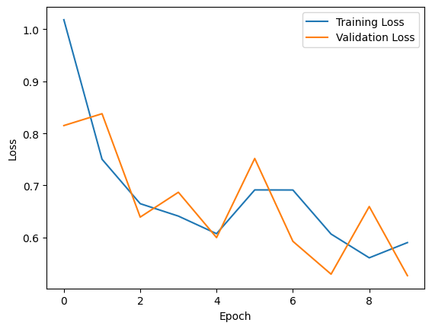

Figure 5: Graph showing training loss and validation loss

Figure 5, shows the graph for training loss and validation loss of neural network model where all the layers in the VGG16 model are frozen (non-trainable).

Table 1: loss and accuracy percentage.

|  |  |
| --- | --- |
| Test loss | 0.6008 |
| Test accuracy | 0.8039 |
| Classifier accuracy | 0.803921568627451 |

Table 1, shows a classifier accuracy of 0.803921568627451. The printed classifier accuracy of 0.803 indicates that the model achieved an accuracy rate of approximately 80.3% on the test dataset. This metric is calculated by comparing the predicted labels generated by the model (y_pred) with the true labels (test_labels) from the test dataset. The accuracy score is determined by the ratio of correctly predicted instances to the total number of instances in the test set. In this context, an accuracy of 0.803 suggests that the model made correct predictions for about 80.3% of the brain tumor images in the test dataset. While accuracy provides a broad measure of overall model performance, it is essential to consider other evaluation metrics, especially in scenarios with imbalanced class distribution or when the consequences of false positives and false negatives differ. Nonetheless, an accuracy of 0.803 is indicative of a reasonably effective model, and further exploration of precision, recall, and the confusion matrix could offer a more nuanced understanding of its performance across different classes.

**6. Ablation Study**

In this is study , an accuracy of 80.3% was achieved by training data at an epochs of 10 for both the frozen and partially unfrozen model. It was observed that at an epochs greater than 10 the accuracy droped to 45-55%.

It was observed that the accuracy dropped when SGD optimizer was used for training and best results were obtained on using adam optimizer.

**7. Conclusion and Future Work**

In conclusion, the implemented Convolutional Neural Network (CNN) for brain tumor classification using VGG16 architecture and transfer learning has undergone training, fine-tuning, and evaluation phases. The model exhibited promising results in accurately distinguishing between normal and tumor brain images, as evidenced by metrics such as accuracy, loss, confusion matrix, and the Receiver Operating Characteristic (ROC) curve. The fine-tuning process, where specific layers of the VGG16 base were unfrozen, contributed to potential improvements in the model's ability to capture task-specific features. However, further analysis and interpretation of individual predictions are essential for a comprehensive understanding of the model's performance.

The above model has been previously seen to be implemented for certain other diseases . In this study we have used brain mri images to detect whether the images have tumor or not.

For future work, several avenues can be explored to enhance the project. Firstly, the dataset could be augmented with additional diverse images to further improve the model's generalization capabilities. Exploring more sophisticated architectures or employing other pre-trained models for transfer learning might provide alternative approaches to address the specific challenges of brain tumor classification. Additionally, incorporating explainability techniques, such as attention mechanisms or interpretable visualizations, could offer insights into the decision-making process of the model and enhance its trustworthiness in medical applications. Collaboration with medical professionals and integration of clinical data could further refine the model and contribute to its practical utility in real-world scenarios. Continuous monitoring and updating of the model with new data would ensure its relevance and effectiveness over time. Overall, the study lays a foundation for robust brain tumor classification, and ongoing efforts can contribute to its continual improvement and adaptation for clinical use.

**References**

[1] B. Chitradevi, P. Srimathi, An Overview on Image Processing Techniques, 2014.

[2] Zhenghao Shi , Lifeng He, Application of Neural Networks in Medical Image Processing, 2010.

[3] Walaa Hussein Ibrahim, Ahmed AbdelRhman Ahmed Osman, Yusra Ibrahim Mohamed, MRI

Brain Image Classification Using Neural Networks, 2013.

[4]Novoneel Chakrabarty,Brain MRI Images for Brain Tumor Detection

<https://www.kaggle.com/datasets/navoneel/brain-mri-images-for-brain-tumor-detection>

[5] Ali Isin, Cem Direkoglu , Melike Sah, Review of MRI-based brain tumor image segmentation

using deep learning methods, 2016.

[6] Arkapravo Chattopadhyay, Mausumi Maitra, MRI-based brain tumtheir image detection using

CNN based deep learning method, 2022.

[7] Sérgio Pereira, Adriano Pinto, Victor Alves and Carlos A. Silva, Brain Tumor Segmentation

Using Convolutional Neural Networks in MRI Images, 2016

[8] Srikanth Tammina, Transfer learning using VGG-16 with Deep Convolutional Neural Network

for Classifying Images, International Journal of Scientific and Research Publications, Volume

9, Issue 10, October 2019

[9] Cui, Z., Yang, J., & Qiao, Y. (2016). Brain MRI segmentation with patch-based CNN approach.

In 2016 35th Chinese control conference (CCC) (pp. 7026–7031). Chengdu, China: IEEE.

[10] Shahamat, H., & Saniee Abadeh, M. (2020). Brain MRI analysis using a deep learning based

evolutionary approach. Neural Networks, 126, 218–234.S.C.B. Lo, H.P. Chan, J.S. Lin et al,

“Artificial Convolution Neural Network for Medical Image Pattern Recognition, ” Neural

Networks. Vol.8, no.7-8 ,pp.1201- 1214, 1995.

[11] K.M.M. Rao "OVERVIEW OF IMAGE PROCESSING" Readings in Image Processing

Fundamentals Of Digital Image Processing - Anil K. Jain, Prentice-Hall, 1989.

[12] Gaurav Kumar, Pradeep Kumar Bhatia"A Detailed Review of Feature Extraction in Image

Processing Systems" 2014 Fourth International Conference on Advanced Computing &

Communication Technologies.

[13] Chaplot, L.M. Patnaik, N.R. Jagannathan “Classification of magnetic resonance brain images,

January 2006, Pages 86-92

[14] J. Seetha, S. Selvakumar Raja, Brain tumour classification using convolutional neural

networks, Biomed. Pharmacol. J. 11 (2018) 1457–1461

[15] W. Zhang, Y. Wu, B. Yang, S. Hu, L. Wu, S. Dhelim, Overview of multi-modal brain tumour

MR image segmentation, Healthcare 9 (2021) 1051.

[16] Daimary, D., Bora, M., Amitab, K., & Kandar, D. (2020). Brain tumor segmentation from MRI

images using hybrid convolutional neural networks. Procedia Computer Science, 167, 2419–

2428.

[17] Zikic D. et al. Segmentation of brain tumor tissues with convolutional neural networks.

MICCAI Multimodal Brain Tumor Segmentation Challenge (BraTS) 2014:36–39.

[18] Liu J, Wang J, Wu F, Liu T, Pan Y. A survey of MRI-based brain tumor segmentation methods.

Tsinghua Science and Technology 2014;19(6):578-595.

[19] Bauer S, Wiest R, Nolte L, Reyes M. A survey of MRI-based medical image analysis for brain

tumor studies. Phys Med Biol.2013;58:97-129

[20] Computer Image Processing And Recognition - Ernest L.Hal, Academic Press, 1979

[21] Digital Image Processing - Kenneth R. Castleman, Prentice-Hall, 1996.

[22] Miller A.S, Blott B.H, Hames T.K. , “Review of Neural Network Applications in Medical

Imaging and Signal Processing, ” Medical and Biological Engineering and Computing. vol.30,

no.5,pp.449-464, September 1992.

[23]Akram, M. U., Khalid, S., & Amin, M. B. (2017). DeepMed: Deep Convolutional Neural Networks for Efficient Medical Image Analysis on GPUs. Computers in Biology and Medicine, 95, 66–77.

[24] Pereira, S., Pinto, A., Alves, V., & Silva, C. A. (2019). Brain Tumor Segmentation using Convolutional Neural Networks in Magnetic Resonance Imaging. IEEE Transactions on Medical Imaging, 37(6), 1440–1451.

[25] Havaei, M., Davy, A., Warde-Farley, D., Biard, A., Courville, A., Bengio, Y., & Pal, C. (2017). Brain Tumor Segmentation with Deep Neural Networks. Medical Image Analysis, 35, 18–31.

[26] Menze, B. H., Jakab, A., Bauer, S., Kalpathy-Cramer, J., Farahani, K., Kirby, J., ... & Reyes, M. (2015). The Multimodal Brain Tumor Image Segmentation Benchmark (BRATS). IEEE Transactions on Medical Imaging, 34(10), 1993–2024.

[27] McKinley, R., Wepfer, R., Gundersen, T. D., Valverde, S., González, G., Salem, M., ... & Rost, N. S. (2020). Predicting Functional and Histological Outcome of Stroke in an Extended Time Window by MRI and Clinical Data. JAMA Neurology, 77(12), 1498–1508.

[28] Kamnitsas, K., Ledig, C., Newcombe, V. F., Simpson, J. P., Kane, A. D., Menon, D. K., ... & Rueckert, D. (2017). Efficient multi-scale 3D CNN with fully connected CRF for accurate brain lesion segmentation. Medical Image Analysis, 36, 61–78.

[29] Ronneberger, O., Fischer, P., & Brox, T. (2015). U-Net: Convolutional Networks for Biomedical Image Segmentation. In International Conference on Medical Image Computing and Computer-Assisted Intervention (MICCAI) (pp. 234–241).

[30] Chang, P., Grinband, J., & Weinberg, B. D. (2018). Deep-learning convolutional neural networks accurately classify genetic mutations in gliomas. American Journal of Neuroradiology, 39(7), 1201–1207.